

SilverCloud Project Initiation Document

Version: | 3
Date: | September 2020
Document ID: | UKCS-0001
Department: | Customer Success

Contract Details
Organisation/Service:
Internal PD ID:
Contract Start Date:
Contract End Date:
Implementation Start Date:
Provisional Go Live Date:
Customer organisations that will have access to service:

Purpose
  - The purpose of this documents is to set out how the SilverCloud Platform is to be implemented in your service, who is involved and their responsibilities.

Project Description
  - The SilverCloud platform will allow users to access evidence-based digital interventions through the service pathway.
  - The platform will give 24/7 access to commissioned interventions.
  - Use of the platform will allow services to increase clinical capacity, reduce waiting lists, increase access rates, offer users a flexible way of accessing services and offer users further choice.
  - A detailed guide to the implementation process can be found here.

Project Team
  - A Programme Manager from SilverCloud will lead the project implementation, working alongside key members of your service to setup a customised platform and support to operationalise it within your service.
  - The SilverCloud Customer Success Manager will carry out training for your service and continue to work with you after the launch to ensure you are getting the best out of your setup.
  - The Implementation Lead for your service should be the day to day contact for managing the implementation within your service.
Please complete the key contacts responsible for your service implementation in the table below.
Nb. Members of the project team can assume more than one role e.g. the service implementation lead may also be the service clinical lead.
Project Team:
Programme Manager (will lead implementation) | SilverCloud | Name: Joanna Rota  Email: joanna.rota@silvercloudhealth.com  Contact Number:
Customer Success Manager | SilverCloud | Name:  Email:  Contact Number:
Implementation Lead | Service | Name:  Email:  Contact Number:
Operation/Service Lead | Service | Name:  Email:  Contact Number:
Clinical Lead | Service | Name:  Email:  Contact Number:
IT/Data Lead | Service | Name:  Email:  Contact Number:
Nominated SilverCloud Champion e.g. PWP lead | Service | Name:  Email:  Contact Number:
Other e.g. Marketing Lead | Service | Name:  Email:  Contact Number:

Service Description, Project Goals, Ambitions and Scope
  - We want to gain an understanding of your existing service and your goals for implementing SilverCloud, so that we can tailor the setup to meet your needs.

Service description | e.g. current selivery model and referral methods
Goals, ambitions and desired outcomes | e.g. benefits to service, service users, clinicians, commissioners etc
Intended usage | e.g. supported and/or unsupported, direct referrals (therapist invite), and/or self-referral
Technical requirements | e.g. potential integrations into paient management systems
Training requirements | e.g. who needs training? How many trainees?
SilverCloud experience | e.g. current understanding of SilverCloud platform, any previous experience
Additional elements and considerations | e.g. other considerations such as phased implementations

Measure of success
5.1 We want to understand what outcomes you will be measuring to ensure that we can support you to reach your targets. This may be KPI’s, outcome measures or engagment numbers.

What e.g. recovery rate, access, satisfaction | How will it be measured | What are the target numbers | When should they be reached | Who is responsible

Implementation Cycle
  - The implementation cycle lasts between 6-8 weeks from project launch. The illustration below gives a high level overview of the process.
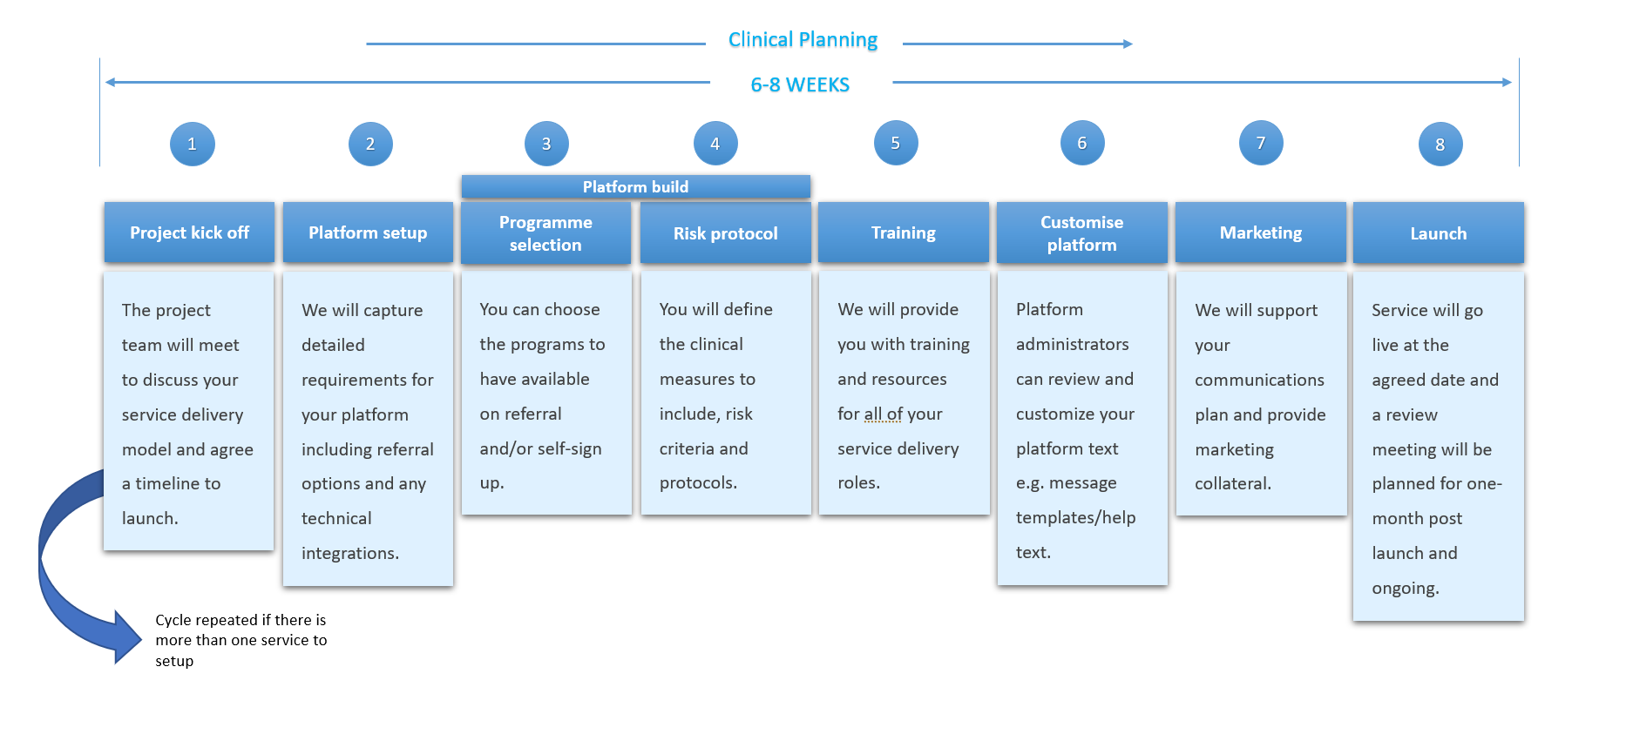
  - To learn more about the process and what’s involved click here.

Project Plan
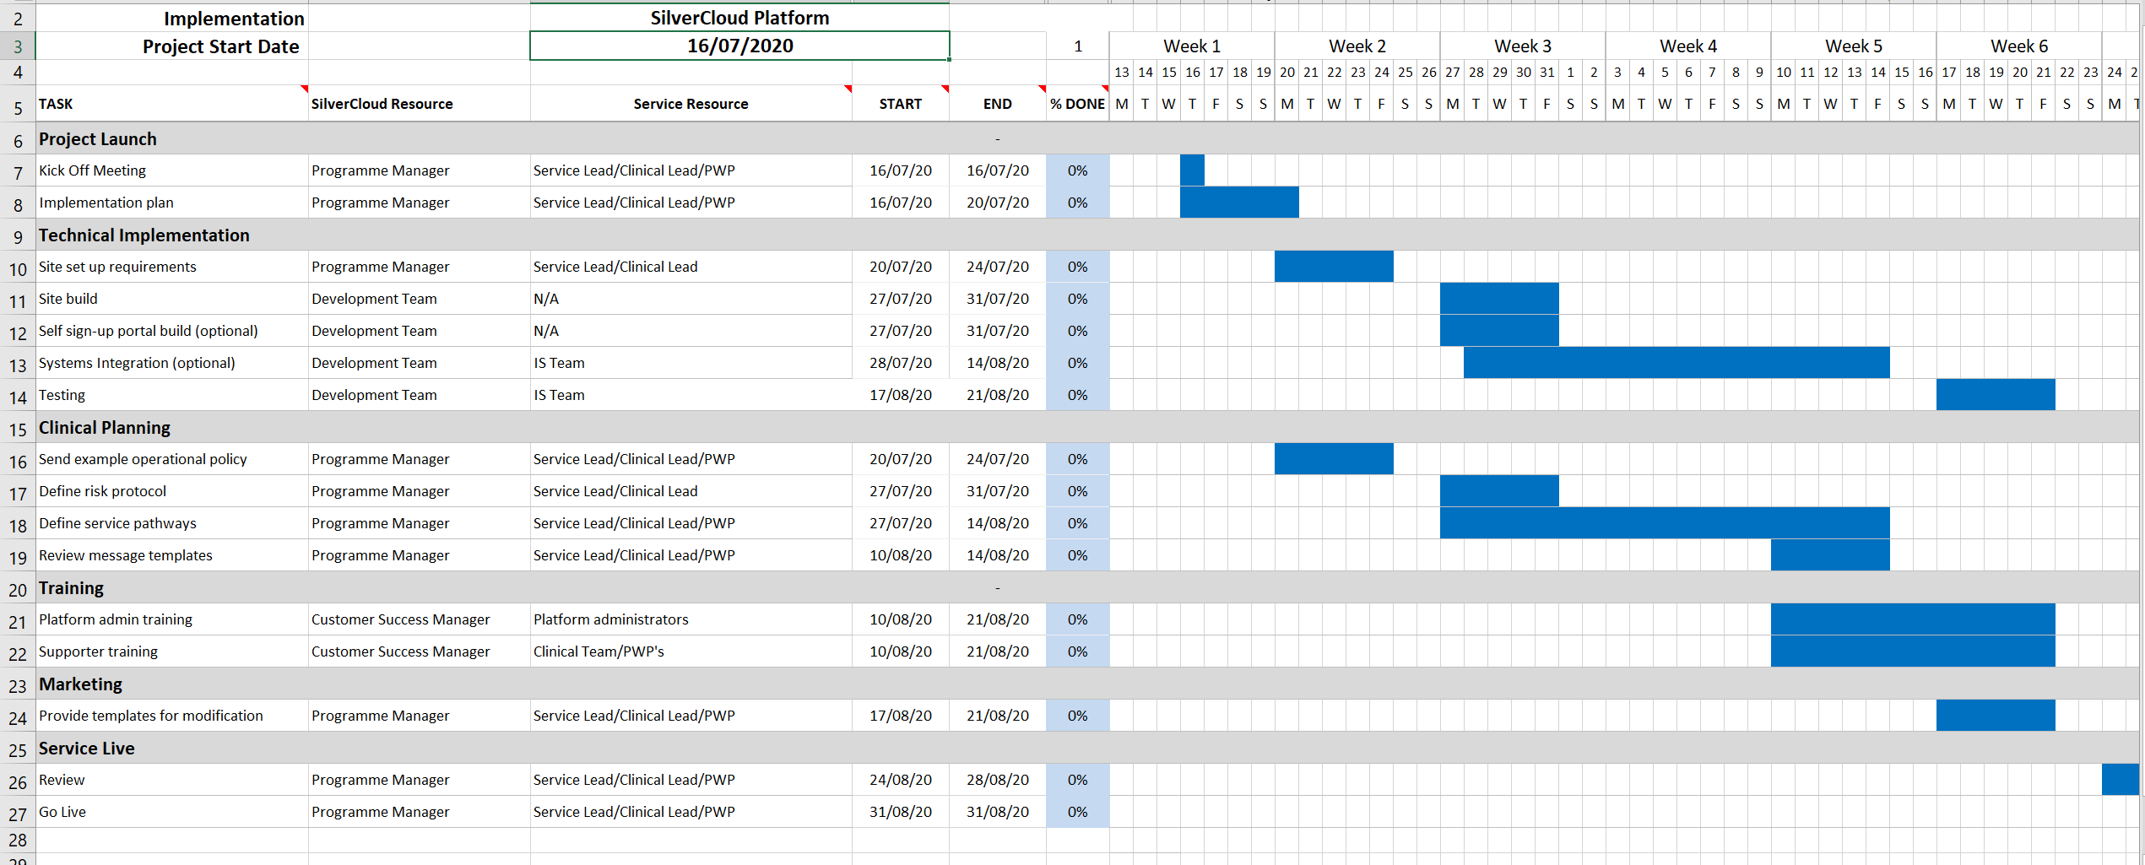
  - Your SilverCloud Programme Manager will develop a detailed project plan with you. See example implementation plan below.

Post implementation
  - The Customer Success team will continue to support you to get the most out of your SilverCloud service post go live.
  - SilverCloud programme manager to document key setup info below:
Go live date:
Handover to CS/BDE date:
Server UK/EU and platform name/UID:
Supported/unsupported:
Invite/self-help:
Additional key info:

