

SilverCloud Project Initiation Document

|  |  |
| --- | --- |
| **Version:** | 2 |
| **Date:** | Oct 2019 |
| **Document ID:** | UKCS-0001 |
| **Department:** | Customer Success |
| **Change Control Number** | 1 |
| **Revisions** | 29/10/19 - Technical set up removed, new implementation process explained |

|  |  |
| --- | --- |
| **Contract Details** | |
| Organisation/Service: |  |
| Internal PD ID: |  |
| Start Date: |  |
| End Date: |  |
| Provisional Live Date: |  |
| Service: | Subscription  Higher Ed  Licence  Mental Health  LTC  Wellbeing  Self Sign Up  Onboarding |

## Purpose

* 1. The purpose of this documents is to set out how the SilverCloud Platform is to be implemented in your service, who is involved and their responsibilities.

## Project Description

* 1. The SilverCloud Platform will allow users to access evidenced based digital interventions throught the service pathway.
  2. The platform will give 27/4 access to commissioned intervetions.
  3. Use of the platform will allow services to increase clinical capacity, reduce waiting lists, increase access rates, offer users a flexabile way of accessing services and offer users further choice.

## Project Team

* 1. The implementation of SilverCloud will be lead by a Customer Success Manger from SilverCloud. This document provide you with details of your Customer Success Manager. They will work alongside key members of your service.
  2. The service imlementation lead will be the day to day contact for managing the implementation within the service.
  3. In some services, members of the project team can assume more than one role e.g. the service implementation lead may also be the service clinical lead

|  |  |
| --- | --- |
| **Project Team** | |
| **SilveCloud Customer Success Manager** | Name:  Email:  Contact Number: |
| **Service Implementation Lead** | Name:  Email:  Contact Number: |
| **Service Operation Lead** | Name:  Email:  Contact Number: |
| **Service Clinical Lead** | Name:  Email:  Contact Number: |
| **Service IT/Data Lead** | Name:  Email:  Contact Number: |
| **Nominated SilverCloud Champion** | Name:  Email:  Contact Number: |
| **Communication/Marketing Lead** | Name:  Email:  Contact Number: |

## Service Description, Project Goals, Ambitions and Scope

|  |  |
| --- | --- |
| Service description | e.g. current selivery model, self referral? F2F? Groups? Current or previous digital provision? Waiting times? etc |
| Goals, ambitions and desired outcomes | e.g. benefits to service, service users, clinicians, commissioners KPI’s etc. |
| Intended usage | e.g. supported, unsupported, across stepped care pathway, direct referrals etc. |
| Technical requirements | e.g. integrations into paient management systems etc. |
| Training requirements | e.g. Who needs training? How many trainees? Venue? Etc. |
| Additional elements and considerations | e.g. Other considerations such as phased implementations |

## Implementation Cycle

* 1. The implementation cycle last between 6-8 weeks from project kick off. The illustration below gives a high level overview of the process. To learn more about the process and what’s involved. [CLICK HERE](https://silvercloud.zendesk.com/hc/en-gb/categories/360001653173-Service-Implementation). Your customer success manager will develop a detailed plan with you.

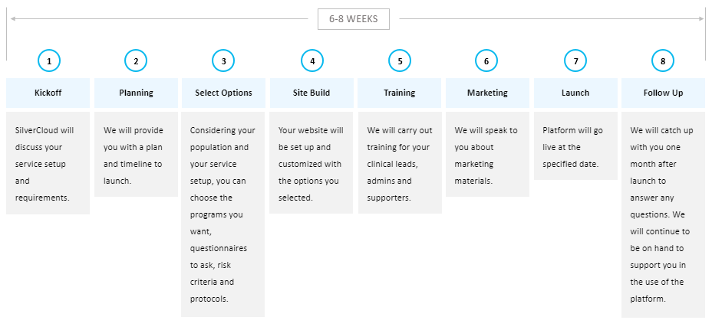

|  |  |  |  |  |  |  |
| --- | --- | --- | --- | --- | --- | --- |
|  | **Implementation Plan** | | | | | |
| **Stage** | **Deliverable** | **Description** | **Hrs/Days/WKS** | **Actions** | **Risks, Issues and Mitigations** |
| Project Lauch | Kick off Meeting Face to Face or Via Webinar (2hrs) | Ensure both parties understand the scope of SilverCloud and define the scope of implementation and agree on project team, roles, and timeline for deliverables | 2 hrs | * Customer Success Manager to lead meeting * Customer Success Manager to complete project plan |  |
| Technical Implementation | Delivey of the SilverCloud Platform | Gather requrements for all technical development aspects including self sign up sites or integrations completing relevant setup documents | 1 WK to gather requirements  2 WKS to build site | * Docuemnts to be sent to service on: * Docuemtns to be returned on: * Platform build complete on: |  |
| Clinical Planning | Service Operational Guidelones | Management of service user pathway from asssessment, supporter allocation, support, risk management through to discharge | 2/6 weeks | * Customer success manager to provide service with guide for operational policy and best practice guide * Service to develop in house process to support delivery of SilverCloud and develop in house pathays on patient management system |  |
| Training | Face to Face or Webinar Training | 2hrs for all supporters and additional staff who may refer or assess users for suitability  1hr for Admin Staff  TOTAL: 3 hours training | 3hrs | * Identfiy number of trainees and confirm dates, times and venue |  |
| Marketing | Communication Pack | Define and develop maketing and communication stratgey within the service and to referrers | From Kick off and ongoing | * Customer success manager to provide appropriate marketing pack (supported/unsupported/both) * Service to outline their commmunication strategy |  |
| Review and Launch | Contact via email/phone | Ensure all plans in place to go live and user are able to access SilverCloud through the service from Live Date | 1 day | * Customer success manager to ensure service has email and contact number for support desk |  |
| Follow up | Contact via phone | Post implementation call to discuss any post go live issues | 1-2hrs | * Schedule ongoing contract and service reviews |  |