WORKPLACE WELLBEING TOOLKIT

POST 1
Graphic Text: A healthier workplace starts with mental health
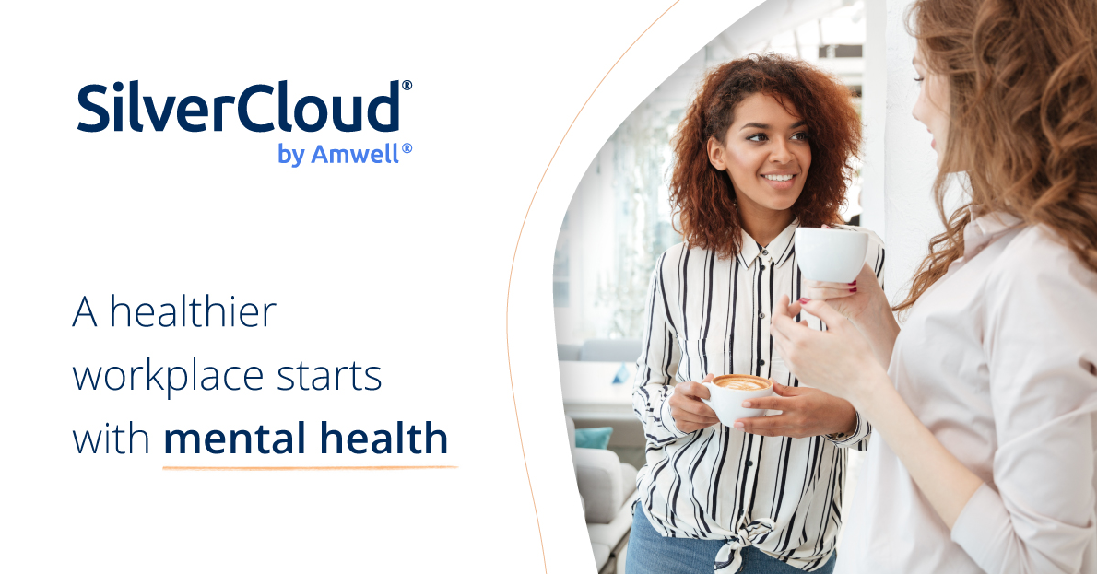
Accompanying copy: Prioritising mental health isn't just a trend. It's a fundamental part of responsible company culture. We’re leading the way in supporting mental health at work by investing in evidence-based digital mental wellbeing programmes from SilverCloud® by Amwell®.
#HealthyWorkplace #ResponsibleLeadership #DigitalWellbeing

POST 2
Graphic Text: Mental health matters, both inside and outside the workplace
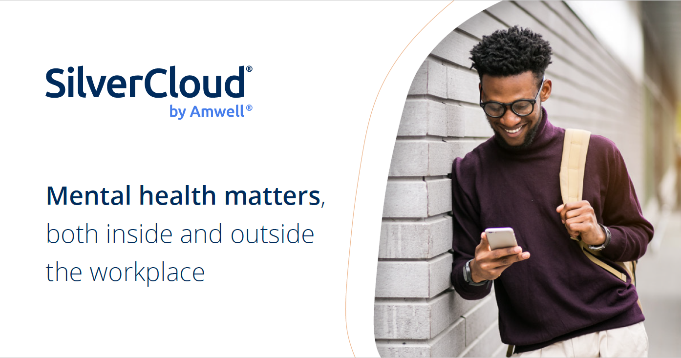
Accompanying copy: We're proud to champion digital mental health interventions for our staff. Investing in SilverCloud® programmes reflects our commitment to our employees' wellbeing, and ensures they have access to proven digital tools for mental wellness whenever and wherever they need them.
#DigitalMentalHealth #EmployeeWellbeing #MentalHealthMatters

POST 3
Graphic Text: Creating a workplace culture that values mental health is not just a choice; it's a responsibility
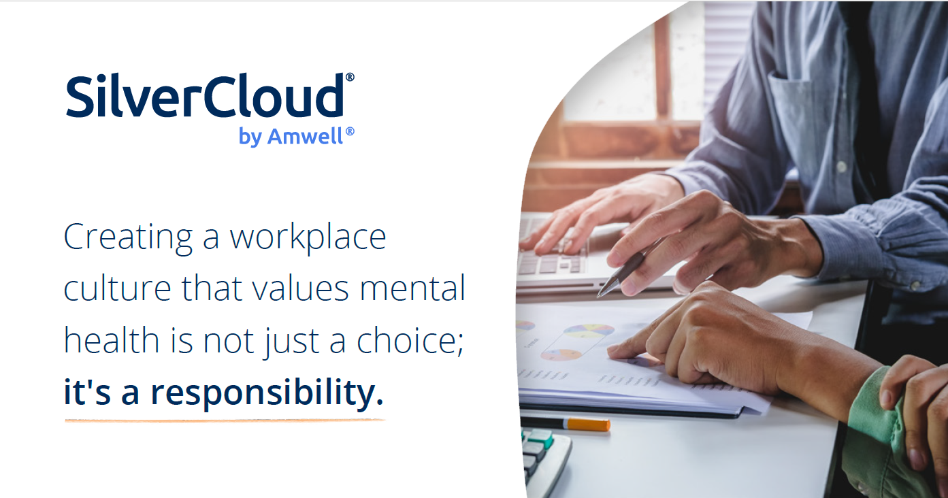
Accompanying copy: Prioritising mental health at work can have a positive impact on productivity, engagement, and overall team satisfaction. At [Company Name Here], we're committed to supporting our team's mental wellbeing by offering digital mental health programmes from SilverCloud® by Amwell®.
#MentalHealthAtWork #DigitalInterventions #EmployeeWellbeing

POST 4
Graphic Text: Supporting whole employee wellness
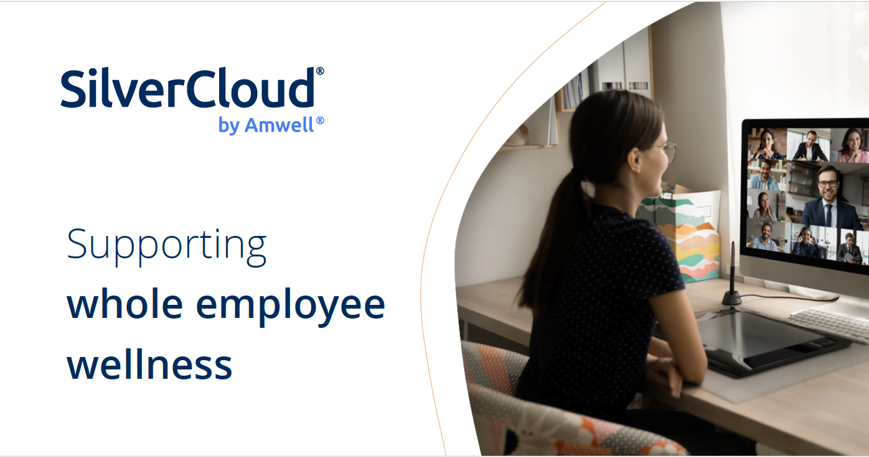
Accompanying copy: It's not just about being responsible employers, it's about creating a thriving, resilient workforce. Alongside physical health, we’ve invested in evidence-based mental wellness programmes from SilverCloud® by Amwell® for the success and happiness of our employees.
#BusinessImpact #MentalHealthSupport #EmployeeEngagement

